

|  |
| --- |
| **Title:** To implement the following point processing techniques in spatial domain:   * Image Negative. * Thresholding. * Gray level slicing * Bit plane slicing |

**Objective:** To learn & understand point processing techniques.

**Expected Outcome of Experiment:**

|  |  |
| --- | --- |
| **CO** | **Outcome** |
| **CO4** | Design & implement algorithms for digital image enhancement, segmentation & restoration. |

**Books/ Journals/ Websites referred:**

1. http://www.mathworks.com/support/
2. www.math.mtu.edu/~msgocken/intro/intro.html.
3. R. C.Gonsales R.E.Woods, “Digital Image Processing”, Second edition, Pearson Education
4. S.Jayaraman, S Esakkirajan, T Veerakumar “Digital Image Processing “Mc Graw Hill.
5. S.Sridhar,”Digital Image processing”, oxford university press, 1st edition."

**Pre Lab/ Prior Concepts:**

**Image Negative:**

Negative images are useful for enhancing white or grey detail embedded in dark regions of an image. Image negatives are obtained by using the transformation function s=T(r).

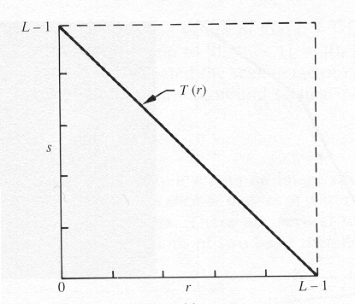

[0,L-1] is the range of gray levels

*S= L-*1*-r*

**Thresholding**

From a [grayscale](https://en.wikipedia.org/wiki/Grayscale) image, thresholding can be used to create [binary images](https://en.wikipedia.org/wiki/Binary_image). The simplest thresholding methods replace each pixel in an image with a black pixel if the image intensity  is less than some fixed constant T or a white pixel if the image intensity is greater than that constant. 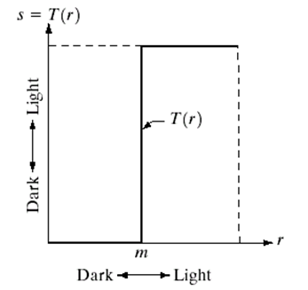

**Gray Level Slicing**

To highlight a specific range of gray levels in an image (e.g. to enhance certain features). One way is to display a high value for all gray levels in the range of interest and a low value for all other gray levels (binary image).

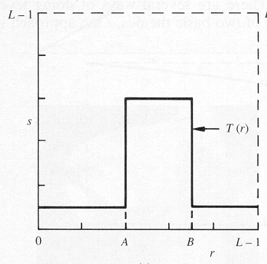

The second approach is to brighten the desired range of gray levels but preserve the background and gray-level tonalities in the image:

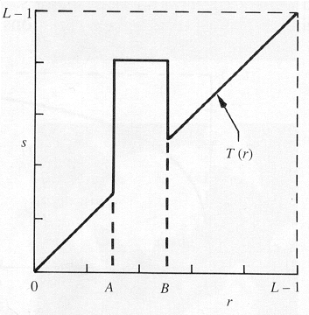

**Bit plane slicing**

Bit plane slicing is used to highlight the contribution made to the total image appearance by specific bits. Assuming that each pixel is represented by 8 bits, the image is composed of 8 1-bit planes. Plane 0 contains the least significant bit and plane 7 contains the most significant bit. Only the higher order bits (top four) contain visually significant data. The other bit planes contribute the more subtle details. Plane 7 corresponds exactly with an image thresholded at gray level 128.

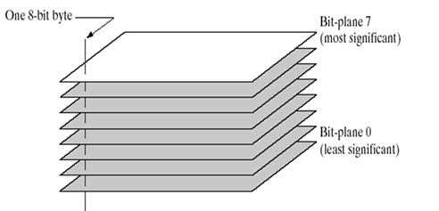

|  |
| --- |
|  |

**Implementation steps with screenshots:**

**CODE**

% Original Image

a=imread('drag.jpg');

figure(1);

% Grayscale Image

imshow(a);

b=rgb2gray(a);

figure(2);

imshow(b);

% Negation

c = 255.-b;

figure(3);

imshow(c);

[m,n] = size(b);

% Thresholding

d = b;

t = input('Enter the threshold value: ');

for i = 1:m

for j = 1:n

if b(i,j)>=t

d(i,j) = 255;

else

d(i,j) = 0;

end

end

end

figure(4);

imshow(d);

% Grayscale Slicing

lower = input('Enter the lower limit of the range: ');

upper = input('Enter the upper limit of the range: ');

% Without background

e=b;

for i = 1:m

for j = 1:n

if b(i,j)>=lower && b(i,j)<=upper

e(i,j) = 255;

else

e(i,j) = 0;

end

end

end

figure(5);

imshow(e);

% With background

f=b;

for i = 1:m

for j = 1:n

if b(i,j)>=lower && b(i,j)<=upper

f(i,j) = 255;

end

end

end

figure(6);

imshow(f);

% Bit Plane slicing

g=b;

[m,n]=size(g);

count='1';

for k = 1:8

h=g;

figure(7);

for i = 1:m

for j = 1:n

h(i,j) = mod(g(i,j),2);

g(i,j) = (g(i,j)-h(i,j))/2;

if(h(i,j)==1)

h(i,j)=255;

end

end

end

subplot(2,4,k),imshow(h);

if(count=='1')

title('Bit-8(LSB)');

elseif(count=='8')

title('Bit-1(MSB)');

else

title(strcat('Bit-',count)); % strcat for concatenating 2 strings

end

count = count + 1;

end

**OUTPUT**

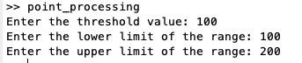

1. **Original Image**

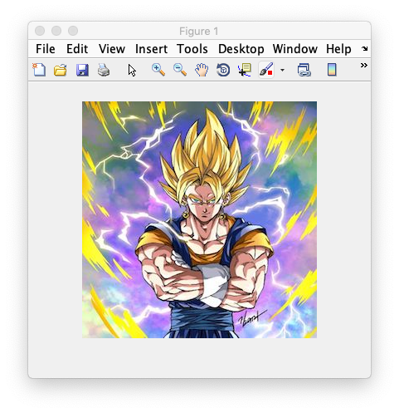

1. **Grayscale Image**

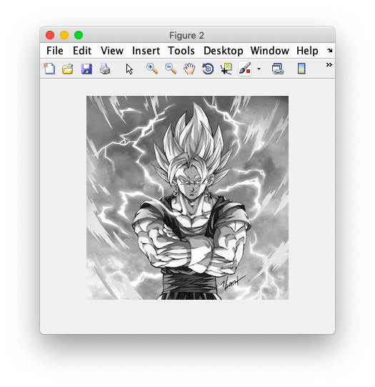

1. **Negation**

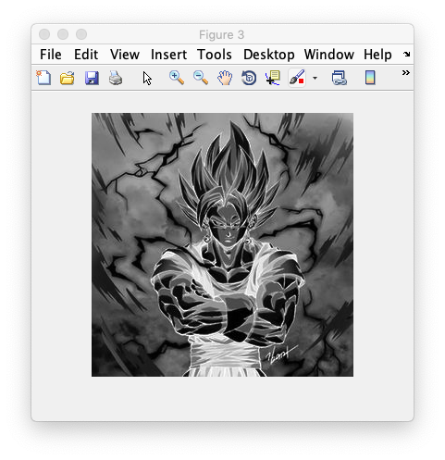

1. **Thresholding (T=100)**

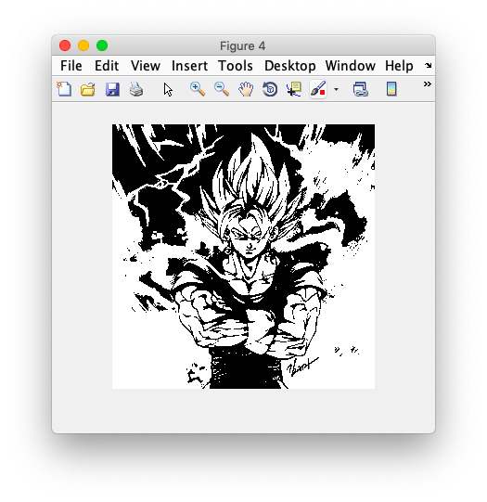

1. **Grayscale Slicing (without background) (Range: 100 to 200)**

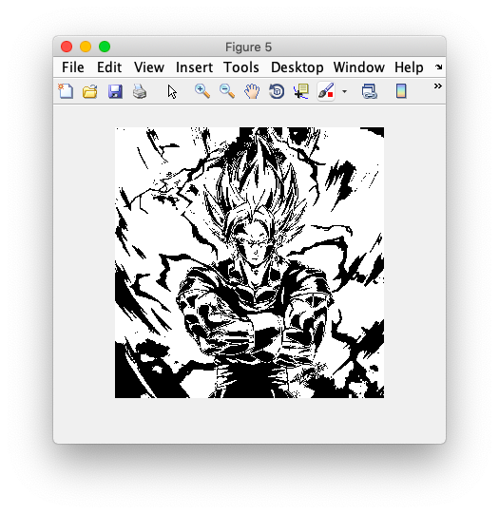

1. **Grayscale Slicing (with background) (Range: 100 to 200)**

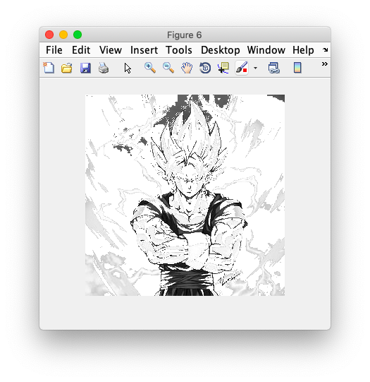

1. **Bit Plane Slicing (LSB to MSB)**

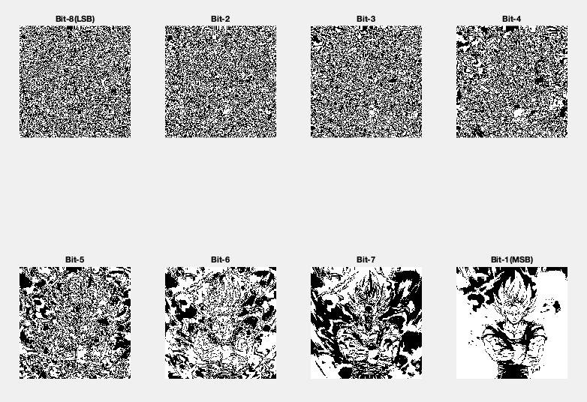

**Conclusion:-**

Thus, we have successfully implemented the point processing techniques in spatial domain.

**Post Lab Descriptive Questions**

1. **Explain the role of bit plane slicing in achieving Steganography concept.**

**Ans.**

BPCS steganography was introduced by Eiji Kawaguchi and Richard O. Eason, to overcome the shortcomings of traditional steganographic techniques such as Least Significant Bit (LSB) technique, Transform embedding technique, Perceptual masking technique. This traditional technique has limited data hiding capacity and they can hide up to 10 – 15% of the vessel data amount. BPCS steganography makes use of important characteristic that of human vision. In BPCS, the vessel image is divided into “informative region” and “noise-like region” and the secret data is hidden in noise blocks of vessel image without degrading image quality. In LSB technique, data is hidden in last four bits i.e. only in the 4 LSB bits. But in BPCS technique, data is hidden in MSB planes along with the LSB planes provided secret data is hidden in complex region.

In BPCS, a multi-valued image (P) consisting of n-bit pixels can be decomposed into set of n – binary pictures. Ordinary image data is represented by a pure binary code system which is commonly used in image processing. However CGC is preferred over PBC in BPCS steganography. Example: P is an n-bit gray image say n=8. Therefore P = [P7 P6 P5 P4 P3 P2 P1 P0] where P7 is the MSB bit plane and P0 is the LSB bit plane. Each bit plane can be segmented into “informative” and “noise” region. An informative region consists of simple pattern while noise-like region consists of complex pattern. In BPCS, we replace each noise-looking region with another noise-looking pattern without changing the overall image quality. Thus, BPCS steganography makes use of this nature of human vision system.

1. **Explain the use of gray level slicing in image processing.**

**Ans.**

Enhancing an image provides better contrast and a more detailed image as compared to non enhanced image. Image enhancement has many applications. It is used to enhance medical images, images captured in remote sensing, images from satellite etc.

Since Thresholding splits the image into 2 sometimes we require some level of the image to be highlighted eg: X-ray, CT-Scan.

Grey level slicing is equivalent to bandpass filtering. It manipulates a group of intensity levels in an image up to a specific range by diminishing rest or by leaving them alone. This transformation is applicable in medical images and satellite images such as X-ray flaws, CT scan. Two different approaches are adopted for

grey level slicing.

**Date: 13/03/2019 Signature of faculty in-charge**